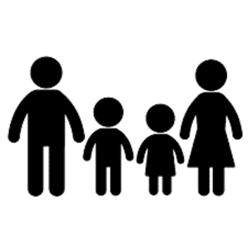
Your Sad Family
Why are they sad? Who is in this family? What do they say? What do they do?
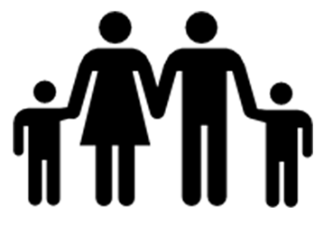
Your Happy Family
Why are they happy?Who is in this family? What do they say? What do they do?
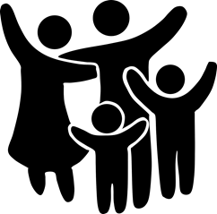
Your Wish Family
Why would someone wish this was their family? Who is in this family? What do they say? What do they do?
Three Families Tool

